My Journey of 8 Months with Automate Accounts (Of course, more to come…)
Designations:
Associate Software Developer – (3 Months Part-Time)
Senior Software Developer – (5 Months Full-Time and continuing…)

Part-Time Days - 4 hrs/day

Starting Few Days (1-2 Weeks)
In the initial week, I spent time getting to know about Zoho and the services it offers. I also completed the setup of company access, accounts, and other required configurations. After that, I started learning about Zoho Catalyst, what different features it offers, how they can be used, and how we currently use them in our work.
It took some time to really understand things. Since it is a PaaS, I initially found it a bit difficult to get familiar with all the names and how everything is referred to the Zoho terminologies. I also spent time learning how the Zoho Catalyst CLI works and how to set things up initially.
At first, I had zero idea how these things worked with Zoho Catalyst, but I realized there was a great learning curve once I started actually using it rather than just reading about how it works.
Everything started to make more sense when I built my first example project with Catalyst. I think it was a Payslip Generator (I don’t really remember the exact name). But yes, it helped a lot in understanding how things work around Catalyst.

1st Project - Certificate of Insurance (COI)
Initial Requirement
The insurance company needed to provide a way for customers to generate a Certificate of Insurance (COI) that they could share with any certificate holder they choose.
An email should be sent to the customer, allowing them to fill in the required details for their preferred certificate and then download the generated certificate.
The goal was to give users two options:
- Either send the certificate request link to the customer, so the customer can fill in the details themselves, or
- The internal team can fill in the details on behalf of the customer (after collecting the information) and generate the certificate.
Customers were only provided with an example certificate and a list of the details that need to be entered.
Another requirement was that each customer should be able to use a different template. At the same time, the company did not want to create templates repeatedly for every request, so the system needed a way to reuse templates efficiently.

Journey of Development-
V1.0
Initially, we built a version where there would be a form to create templates. Once a template was created, users could use that template to fill in the certificate form. They had the option to either send the certificate request to the customer for completion or fill in the certificate holder’s details themselves.
We also provided a preview feature, allowing users to see the certificate with the details they were entering.
If the option to send it to the customer was selected, an automated email would be sent to the customer. The customer could then log in using an OTP, fill in the required details, and submit the form. Once submitted, the certificate would be generated, and the customer could download it securely.
V1.1
In the next version, the customer requested that templates must be unique for every customer. To support this, we updated the system so that templates could be created at the Contact/Customer level.
They also requested the ability to copy templates from one customer to another, so we added that feature as well.
Now, once a customer is selected in the certificate form, the user can see all the templates created for that specific customer. The user can then choose a template and fill in details such as deductibles, amounts, and other required fields.
V2.0
In this version, the feature that allowed sending the certificate form to customers for completion was removed, based on the customer's updated requirements.
We also added the ability to edit previously created certificates. Additionally, version control was introduced to maintain a history of all created certificates.
Some additional features were also added, including:
- The ability to download all issued certificates as a CSV file
- The template copy feature from one customer to another was further improved and integrated into the workflow.
V2.1
In this version, we changed how template data is handled.
All the details required in the template must now be entered during template creation itself. In the certificate form, editing template fields was disabled to ensure consistency.
We also introduced a dropdown-based template field loader. Based on the selected dropdown value, the relevant template fields are automatically loaded, reducing the need for manual entry of fields and values.
Additionally, several minor improvements and enhancements were implemented to improve usability and workflow.

Challenges Faced
- One of the major challenges was that the requirements from the customer kept changing during almost every call. Because of this, we often had to rethink and adjust the implementation multiple times.
- A significant amount of effort went into building the first version, where the core idea was to create templates once and reuse them efficiently. Achieving this technically required a lot of work, especially in terms of designing the template structure and ensuring it could be reused across different certificates.
- Another important consideration was that the entire application needed to be simple and easy to understand for the customer. To make the user experience smoother, we tried to keep the workflow as simple and straightforward as possible.
- For example, we added features such as a certificate preview, which allows users to see how the certificate will look in real time while entering the details.
- On the technical side, we initially chose Zoho Catalyst NoSQL as our database service. However, when we migrated from the US Data Center (US DC) to the Canada Data Center (CA DC), we discovered that Zoho Catalyst NoSQL was not available in CA DC. Because of this limitation, we had to migrate the entire database setup to MongoDB (NoSQL) in order to continue supporting the application.
- Another major challenge was hosting the frontend using AppSail in Zoho Catalyst. Sometimes, even after deploying the latest version, the system would still run older cached versions of the application. To resolve this, we often had to delete the existing deployment and redeploy the application as a new instance.
- IThis caused another issue: the application URL would change every time we redeployed, which meant we had to update the COI URL in all the places where it was being used.

Results
- Once the feature was fully built and delivered to the customer, there have been almost no complaints or support tickets regarding its functionality. The system has remained stable and reliable since its release.
- There has been only one reported issue so far, which was identified and resolved within a few hours.
- The solution significantly simplified the certificate generation workflow, allowing users to reuse templates, generate certificates quickly, and maintain consistency across customers. The template-based approach also made the system flexible enough to support multiple customer requirements without repetitive configuration.
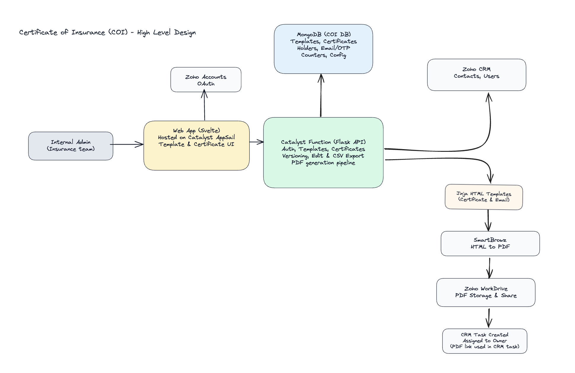

2nd Project Apollo Integration

Initial Requirement
The requirement was to bring all the leads from Apollo into the Zoho Marketing Automation leads list so that they could be used for marketing campaigns and automation workflows.

Journey of Development
Initially, I focused on understanding the requirement and identifying the best approach to solve the problem.
The solution involved mapping the list IDs between Apollo and Zoho Marketing Automation. To achieve this, I created a mapping table that stores the corresponding Apollo list IDs and Zoho Marketing Automation list IDs.
Next, I worked on setting up a scheduled synchronization process. I explored how to configure cron jobs in Zoho Catalyst and implemented a daily scheduled job to automate the synchronization process.
When the cron job is triggered:
- It calls the Apollo APIs to fetch the latest lead data.
- The data is then synchronized with the corresponding Zoho Marketing Automation lists.
The integration supports a one-way sync from Apollo to Zoho, but it handles both additions and removals:
- If a new lead is added in Apollo, it gets added to the corresponding Zoho Marketing Automation list.
- If a lead is removed from Apollo, it is also removed from the Zoho list to maintain consistency.
The integration was hosted using Zoho Catalyst Advanced I/O Functions, and the cron scheduler was used to run the synchronization automatically on a daily basis.

Challenges Faced
- One of the challenges was that Apollo contains multiple lead lists belonging to different categories. For each of these lists, a separate corresponding list needed to be created in Zoho Marketing Automation. Because of this, some time was spent designing and implementing the mapping between Apollo lists and Zoho Marketing Automation lists.
- Another challenge was obtaining and configuring the Apollo API secret key required to access the lead data. This took some time to set up properly.
- Additionally, I spent time understanding Apollo API terminologies and how their APIs work, including how to fetch leads, manage lists, and handle synchronization logic.

Results
- The integration has been running successfully at scale without any major issues since its deployment.
- Recently, it was discovered that Apollo has updated several of its APIs, so the integration now requires updating the existing API endpoints and logic to align with the latest Apollo API changes.
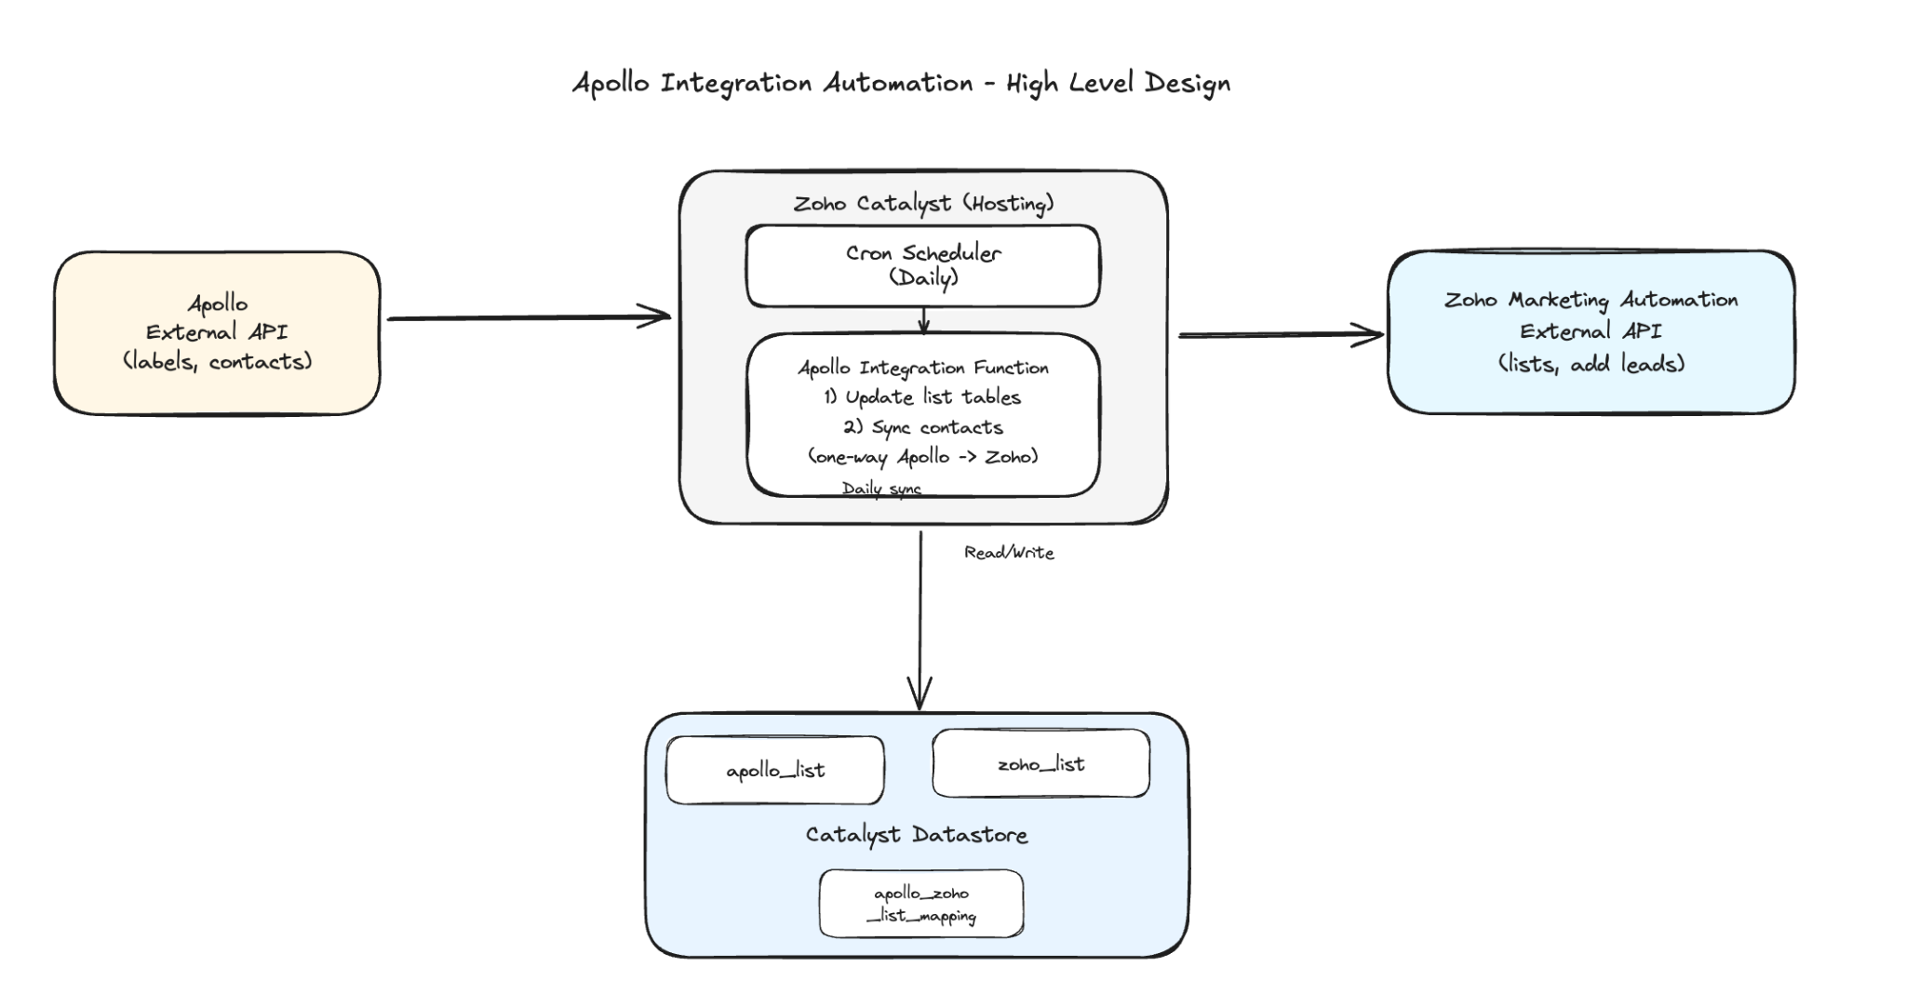

3rd Project – AIM Invoicing
(Initial days of full-time – 8 hrs/day)

Initial Requirements
The requirement was to create an invoicing system where an invoice can be generated for a customer based on a policy record. Once the invoice is generated, it must be stored in Zoho WorkDrive.
The application also needed to support different payment methods, such as:
- Manual payment
- EMI payment through IPFS
For EMI payments, the system needed to integrate with IPFS webhooks, so that once the payment is completed, the webhook would update the payment status in the system.
There was already an existing application called SNAP running in the US Data Center (US DC). The new application needed to replicate the functionality of SNAP in the newly migrated Canada Data Center (CA DC), along with some improvements in the workflow and implementation.
Another major constraint was the timeline — the entire development had to be completed within a single weekend and deployed live.
Additionally, if a policy record ID is passed through a query parameter, the system should automatically load the corresponding policy data and pre-fill the invoice form to make invoice generation faster and more convenient.

Journey of Development
Since we had to implement functionality similar to the existing SNAP application, I referred to it as a baseline for understanding the workflow and features.
The first step was to implement contact selection, along with a search functionality to find contacts. This component was reused and adapted from the previous COI project. Once a contact was selected, I added functionality to load all associated policies and allow users to select a policy and fetch its details.
Next, I spent time understanding the invoicing structure, including:
- Different fields required for invoice creation
- How line items should be structured and loaded
- How tax calculations need to be handled
After retrieving all the required data from the policy record, I worked on creating invoices via APIs, including:
- Adding line items correctly
- Passing item IDs to the invoice API
- Handling API constraints and limitations
Once the core invoice creation was complete, the next major focus was on IPFS payment integration:
- Generating payment links for EMI/IPFS-based payments
- Implementing backend logic to handle IPFS webhooks
- Updating invoice/payment status automatically when payment is completed
Finally, I worked on the PDF generation process, where:
- The invoice is converted into a PDF document
- The generated PDF is stored in Zoho WorkDrive
- The user is redirected to view/download the generated invoice PDF

Challenges Faced
One of the initial challenges was understanding how invoicing works, along with learning the Zoho Invoice APIs. It required careful understanding of how line items need to be structured and passed with the correct item IDs, as invoices are only created successfully when these mappings are accurate.
Another challenge was with IPFS payment link creation, as there was no proper documentation available. The API required sending requests in XML format, which made it difficult to structure and pass the required values correctly. This took some time to figure out, but it resulted in a strong learning experience.
A major challenge was the tight deadline — the entire application had to be designed, developed, and deployed within a single weekend, which required quick decision-making and rapid development.

Results
Since the application was built over a weekend, there were a few initial hiccups during the first 1–2 days after release. However, after addressing those early issues, the system became stable and reliable.
Over time, additional improvements were made to validations based on the tickets raised, which further enhanced the user experience.
Overall, after the first week of release, there were no major issues, and the system has been running smoothly since then.
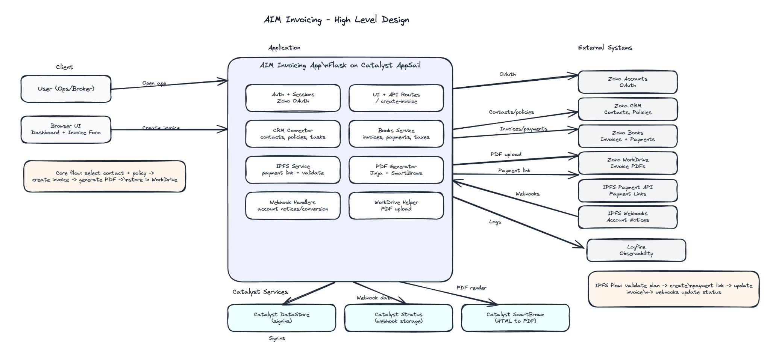

4th Project – E&O Application Revamp (AIM)

Initial Requirement
There was an existing E&O application that was unstable and unreliable, often failing to complete its intended workflows. The goal was to completely revamp and rebuild the application, ensuring it works smoothly and handles the entire process without errors.
Both renewals and new applications needed to be treated as new business, and all the corresponding business logic had to be implemented accordingly.
Another key requirement was to implement dynamic policy pricing, where:
- The pricing is calculated based on user inputs
- Various business rules and conditions are applied
- Proper validations and “kickout” conditions are enforced if certain criteria are not met
The system needed to ensure accurate pricing, strict validation, and a seamless user experience throughout the application flow.

Journey of Development
We started by building the frontend, implementing all the required forms and fields. The application consists of a multi-step flow (around 12 steps), including form inputs, selections, and payment. We ensured proper handling of mandatory fields at each step and implemented progress saving, allowing users to navigate back and forth without losing data.
To improve user experience, we introduced a system where a unique application ID is generated at the start of the form. This allows users to resume their application from where they left off, and the application ID is also sent to the user via email for easy access.
Next, we focused on implementing the core business logic, including:
- Kickout conditions, where users are disqualified if they do not meet certain policy criteria
- Dynamic premium calculation, where pricing is adjusted based on user inputs across the form
Once the core logic was implemented, we conducted a review with the customer and then proceeded to the next phase, which included payment integration and final submission steps on the frontend.
This involved:
- Generating payment links by sending all required application details
- Handling post-payment user flow and completion steps
After completing the frontend, we moved on to the backend development, designing microservices to handle post-payment operations.
One of the key components was webhook-based processing:
- Once a payment is completed, a webhook is triggered
- This webhook acts as a trigger for backend workflows
Upon receiving the webhook, the backend performs a series of operations:
- Create a policy record in the database
- Sync and create the record in the CRM system
- Generate an invoice
- Create policy documents based on user inputs
The system also determines whether to generate:
- Only an LA policy, or
- Both LA and CA policies, depending on the customer’s inputs
Finally, the generated policy documents are stored in Zoho WorkDrive and sent to the customer via email, completing the entire application flow.

Challenges Faced
The biggest challenge I faced in this project was understanding complex insurance terminology, what each term actually means and how different fields impact one another within the application.
Although we had an existing E&O application from CloudLion, there was no proper documentation available. We had to go through the existing codebase, understand the underlying logic, and reimplement it from scratch.
Another difficulty was that the existing logic was poorly structured and spread across multiple files with confusing naming conventions. This made it extremely challenging to trace, understand, and correctly replicate the business logic.
On top of these challenges, there was significant time pressure. The renewal dates were approaching, and the client expected the application to be completed within a few days of starting development. This led to some very intense days spent understanding requirements, debugging, implementing features, and iterating quickly.
Additionally, while working on this project, we were also handling the migration from US DC to CA DC, which brought in additional requests, issues, and operational challenges. At the same time, the client requested additional features to be implemented within a short timeframe (less than a month).
Overall, this period—working on both the E&O Revamp and the Invoicing application—was easily one of the most challenging phases at Automate Accounts, requiring constant problem-solving, adaptability, and sustained effort under pressure.

5th Project – Policy Scan Docs (AIM)

Initial Requirement
In this system, whenever an email is sent to a configured WorkDrive email address, the attached files are automatically saved to Zoho WorkDrive.
A trigger is set up to pick up these files and create a task based on them. The entire workflow is implemented using Zoho Flow.
However, there were some key issues in the existing setup:
- Zoho Flow has a 30-second response timeout limitation. If any process takes longer than 30 seconds, the request fails due to timeout.
- An AI integration was already in place, which processes documents in two steps:
  - Reads and extracts data from the attachment
  - Identifies whether a policy number exists in CRM
    - If found, the created task is assigned to the corresponding policy owner
The challenges in this setup were:
- The 30-second timeout issue, especially when processing large or complex documents
- Multiple tasks being created for each attachment, including unnecessary files like images

Journey of Development
To eliminate the 30-second timeout issue, we needed to move the document processing logic outside of Zoho Flow, since Zoho Flow has strict execution time limits.
To solve this, I decided to use Zoho Catalyst Functions.
The updated flow works as follows:
- Zoho Flow is now responsible only for detecting when a file is saved to WorkDrive
- Instead of processing the document directly, it calls an API endpoint
Once the API endpoint is triggered:
- It creates a record in the Catalyst DataStore
- I configured the system such that whenever a new record is added to the table, a Catalyst function is automatically triggered
When the function is triggered:
- It downloads the file from WorkDrive
- Sends it for processing
- Handles task creation based on the processed data
Previously, document processing was done in two steps:
- Extracting data
- Identifying the policy number
I optimized this by combining the logic into a single-step processing flow, where the system directly extracts and identifies the policy number.
Based on the detected policy number:
- The system searches for the corresponding record in CRM
- Assigns the task to the respective policy owner
If anything goes wrong during the process:
- A default task is created, ensuring that no document is missed and can be reviewed manually

6th Project – Lead Email Notification for Home & Auto (AIM)

Initial Requirement
Previously, emails were being sent out a certain number of days before expiry using a Zoho workflow. However, the client required that emails should be sent irrespective of the year, meaning the logic should work every year continuously based on expiry dates.
This requirement could not be fully achieved using Zoho Workflows, as they do not support triggers that work independently of the year in this manner.

Journey of Development
To overcome this limitation, I chose to implement the solution using Zoho Catalyst, which provided the flexibility needed for customization.
I developed a system that:
- Sends email notifications 20 days and 45 days before the expiry date
- Continues to trigger every year until the lead status is marked as “Won”
Additionally, I worked on updating the email templates:
- Removed or adjusted the year references in expiry dates
- Ensured that emails appear relevant and not confusing, even if the original expiry year is old
This approach ensured a consistent and automated notification system, independent of year-based workflow limitations.

7th Project – LinkedIn Links Loading (PRG)

Initial Requirement
The requirement was to fetch LinkedIn profile details based on the contact’s username and company.
Additionally, the system needed to:
- Fetch the company’s LinkedIn profile using the company name
- Retrieve the company logo from LinkedIn
- If a website is available, extract the company logo from the website as well

Journey of Development
To implement this functionality, I configured three separate functions, each handling a specific responsibility:
- Profile Enrichment Function
  - Fetches the LinkedIn profile URL and profile logo based on the contact’s name and company
  - Also retrieves additional details such as the current position, if available
- Company LinkedIn Lookup Function
  - Retrieves the company’s LinkedIn profile URL using the company name and location
- Company Logo Extraction Function
  - Fetches the company logo from the website, if a valid website is available
This approach helped in keeping the logic clean, reusable, and easy to maintain for Create and Edit.

Challenges Faced
One of the main challenges was that the success rate of fetching LinkedIn profiles was relatively low. This was mainly because names and company details may not always match exactly, leading to fewer accurate results.
However, we made a conscious decision to prioritize accuracy over higher return rates. Instead of returning potentially incorrect matches, the system was designed to only provide results when there is a high level of confidence, even if that meant fewer results overall.

8th Project – WorkDrive Links Migration (US DC → CA DC) – AIM

Initial Requirement
As part of the migration, the client’s CRM database was moved from the US Data Center (US DC) to the Canada Data Center (CA DC).
However, many existing tasks created in the US DC contained WorkDrive links pointing to US DC files within their descriptions. After migration, these links became inaccessible, since the corresponding WorkDrive data was also moved to CA DC.
The requirement was to update all such task descriptions, replacing US DC WorkDrive links with the correct CA DC links, ensuring continued accessibility.

Journey of Development
To implement this, the first step was to identify the corresponding file location in CA DC.
The approach followed was:
- Extract the file ID and folder ID from the existing US DC WorkDrive link
- Retrieve the folder name associated with the file
- Search for the same folder in CA DC WorkDrive
If the folder was not found:
- Retrieve the parent folder name
- Perform a hierarchical search until the correct folder is located
Once the folder was identified:
- Search for the file by name within that folder
- If the file is found, generate the new CA DC WorkDrive link
- Replace the old US DC link in the task description with the new CA DC link
This ensured that all migrated tasks correctly point to accessible WorkDrive files in CA DC.

9th Project – Blueprints (PRG)

Initial Requirement
The client was using Zoho Projects and required additional workflow control features.
The requirements were:
- When a task is created, it should be sent for review before completion
- A task should be marked as completed only after approval from the concerned person
- Email notifications should be sent:
  - When a task is assigned
  - When a task is sent for review

Journey of Development
To implement this, I utilized the Blueprint feature in Zoho Projects to design and enforce the required workflow.
I configured the blueprint to:
- Introduce a review stage before task completion
- Ensure that tasks can only move to the completed state after approval
Additionally, I set up Zoho workflows to handle:
- Email notifications on task assignment
- Email notifications when a task is sent for review
This ensured a more structured approval process and improved task tracking within the system.

Medium one

10th Project – Azure AVD VM Setup for AIM Users (ARS & PowerBroker)

Initial Requirement
The objective was to set up Azure Virtual Desktop (AVD) environments for AIM users to support:
- Applied Rating Services (ARS)
- PowerBroker (PB)
This included ensuring proper installation, data migration, performance optimization, and seamless accessibility for all users.

Journey of Development

ARS Installation & Deployment
Initially, the ARS installation was completed according to documentation; however, existing data was not reflecting correctly. We coordinated with the Applied Rating Services support team, but the issue remained unresolved.
To overcome this:
- We removed the existing installation and restarted the setup from scratch
- Resolved multiple issues through step-by-step troubleshooting and research
- Successfully completed the full ARS setup
Additionally:
- The existing database was on a free developer edition, which had a 10 GB limitation
- Since the data exceeded this limit, we upgraded to a Pay-As-You-Go Enterprise edition
- As there was no direct upgrade path from Microsoft:
  - A new VM with an enterprise license was created
  - Required files were migrated to the new environment
  - The system was reconfigured accordingly
Finally:
- The database was updated with the latest version from the Lifeline server, ensuring accurate and up-to-date data

PowerBroker Installation & Migration
For PowerBroker:
- Migrated approximately 500 GB of data from the old server to a new Azure server
- Followed official documentation to ensure a correct and stable setup
To optimize migration:
- Used Azure Blob Storage:
  - Uploaded all PowerBroker data to a Blob container
  - Downloaded it onto the new server
- This approach enabled fast and efficient migration within a few hours without data loss
Further steps included:
- Completing full system setup as per documentation
- Scaling the server to handle high data volumes
- Configuring user roles and permissions
- Adding all AIM users to the Azure tenant
We also coordinated with PowerBroker support for assistance during migration, including remote troubleshooting if required

Outcome
- Successfully deployed Azure AVD environments for ARS and PowerBroker
- Achieved stable performance with large-scale data handling (500GB+)
- Ensured secure and structured user access for AIM users
- Delivered a fully functional, production-ready cloud setup

11th Project – Territory Assignment Automation (AIM)

Initial Requirement
- Here the requirement from client is, to assign a policy to particular Terriory. So this can be used in reporting for the client.

Journey of Development
To implement this, we designed a logic flow based on producer information:
- Retrieve the Producer Name/Code from the policy record
- Fetch the Producer Email from the Producers module
- Use the email to identify the seating location from Zoho People
- Map the seating location to the corresponding territory in Zoho CRM
- Assign the territory ID to the policy record

Automation for New Policies
We implemented a fully automated workflow for new policy creation:
- System retrieves Producer details from the policy
- Fetches email from the Producers module
- Identifies seating location via Zoho People
- Maps it to the correct territory
- Automatically assigns the territory to the policy
This ensures:
- Consistent and accurate territory assignment
- Zero manual intervention for new records

Handling Missing / Inactive Producers
There were cases where:
- Producers were missing or inactive
- Territory details were provided externally for such producers
- These policies needed to be moved under the House Producer category
Based on the provided data:
- Identified producers with:
  - Missing seating location
  - Inactive or undefined mappings
- For such cases:
  - Assigned territories using the provided sheet/data
  - Reassigned policies to the House Producer category
This ensured:
- No policy remains unassigned or incorrectly mapped
- Continuity in reporting and operations

Mass Update for Existing Policies
In addition to new records:
- Initiated a bulk update process for all existing policies
- Applied the same logic:
  - Territory mapping via seating location
  - Reassignment to House where required
Challenges:
- Zoho API rate limits restricted updates per day
- The process was executed in phases over multiple days

Outcome
- Achieved end-to-end automation of territory assignment
- Eliminated manual effort and data inconsistencies
- Ensured all policies are:
  - Properly mapped to territories
  - Assigned to House Producer when required
- Delivered a scalable and maintainable solution for reporting and operations

12th Commissions Project-AIM

